登入網站: www.weebly.com
Login email: studentnumber@logosacademy.edu.hk
Password: Create one

You may choose the language you like
可選擇中文或英文介面
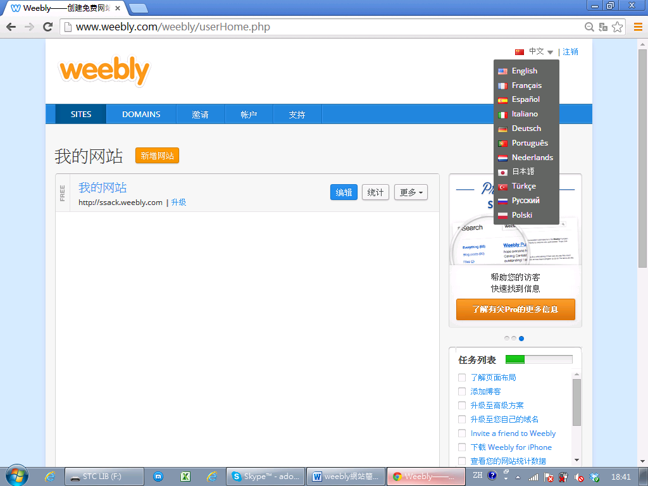
按編輯開始做網頁
Adding new page
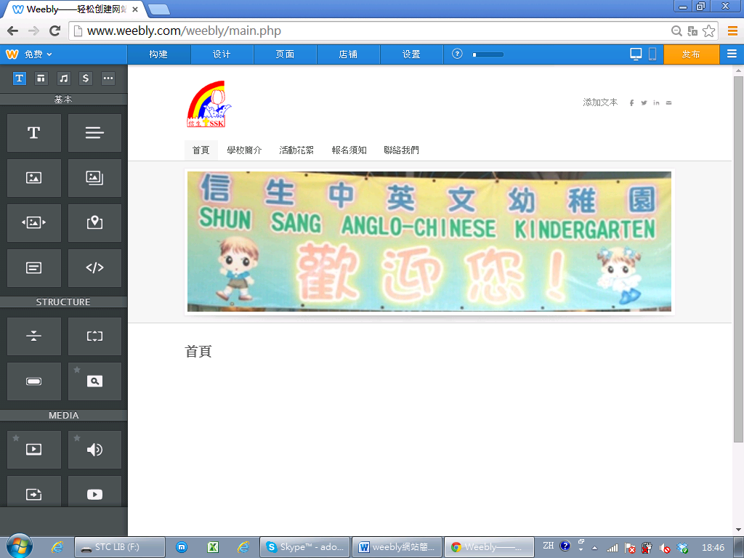

Add text in page
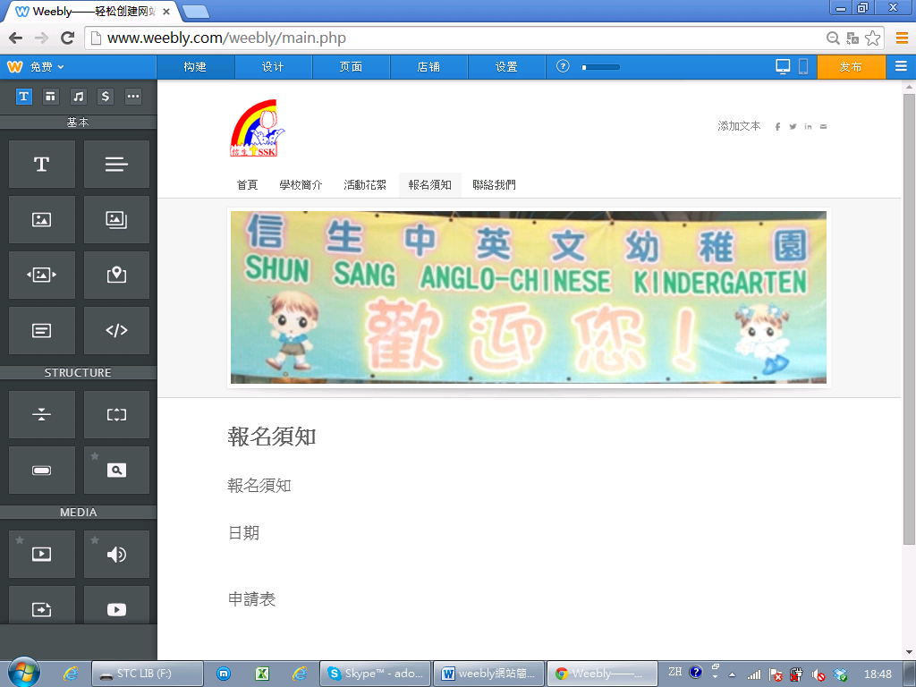
你可以自由更改文字

If you would like to add document like word or excel, highlight text and click Create Link.
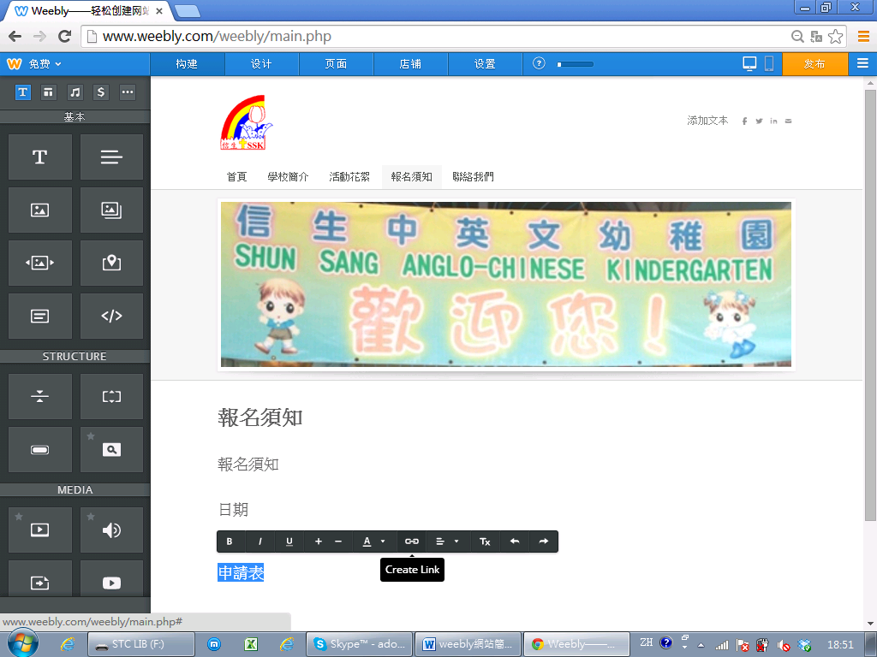

Upload your file
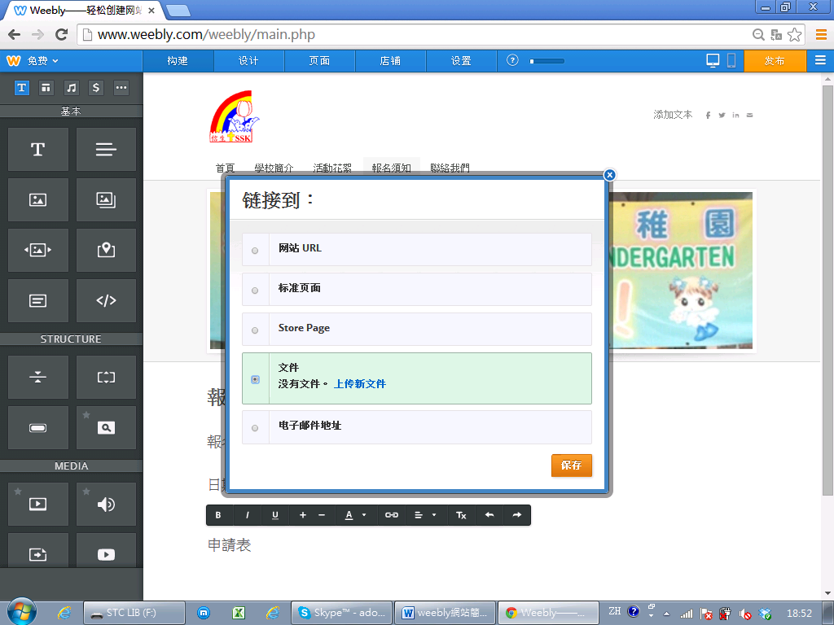

File added
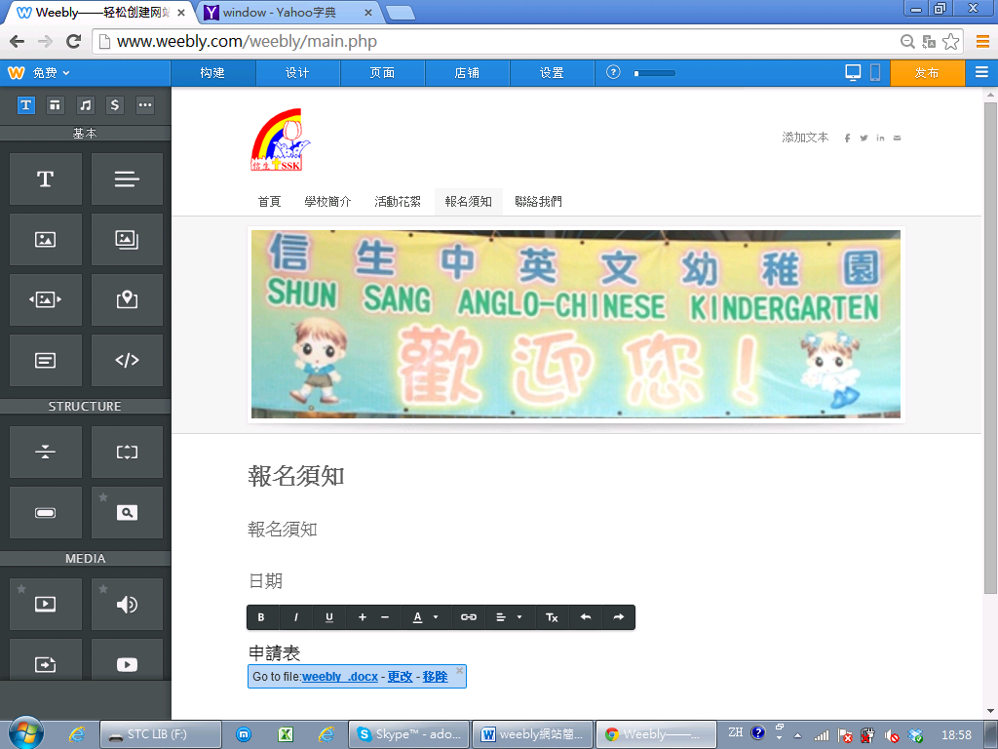

Upload you website

Click the blue link to view your website
